BN, Mar 27, 2019

Customer: P & S Machine & Fabrication, Inc.

**We have 2 projects:**

**1/Daily Flash Report:**

**Numbers need to capture:**

a.All orders entered the day before with a due on or before the 15th of the following month.

b.Total amount Invoiced from the previous day.

c.Total amount due on our open orders report of items due on or before the 15 of the following month.

d.Total Amount that was entered into Accruals for Payables on the previous day.

The Daily Number will be emailed to Managers whose emails are setup in the maintenance program:

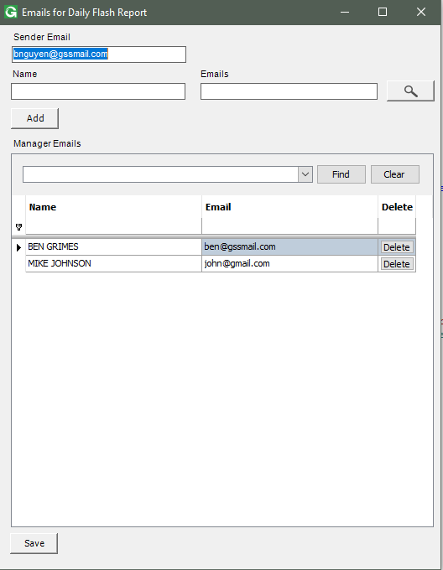

* Emails will be sent to Managers every 9am daily.
* If run from a custom menu item, it won’t send emails, but will open a message showing the Daily Numbers:

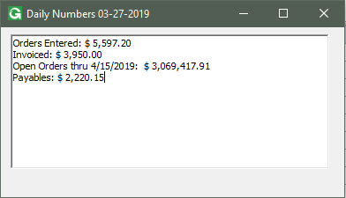

**2/ Weekly Time & Attendance Report:**

Specs:

 2.1 From a custom menu item, user will open a form to select the date range (default to current date).

Select a date will auto-populate days of the weeks (Mon,Sunday). We keep the rule: the week starts on Monday and end on Sunday.

2.2 Click Looad will generate a dashboard that can be exported to an Excel file and will be saved to a default/selected folder.

2.3 The data to be looked up will be in table Time_Attendance with Flag Paid = ‘Y’

2.4 The program can be attached to the Task Scheduler that will be run on every Sunday at 11:59 pm. This will automatically generate the Excel file to a default folder, then email this file to a list of emails specified in a maintenance program.

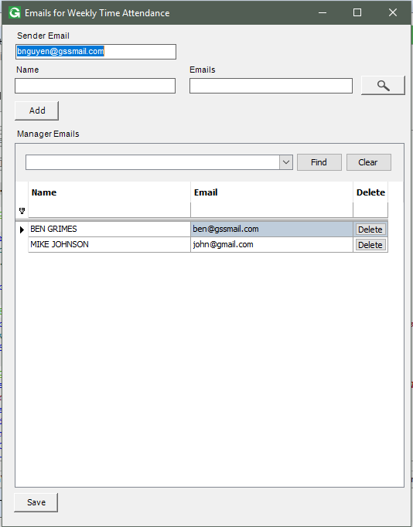

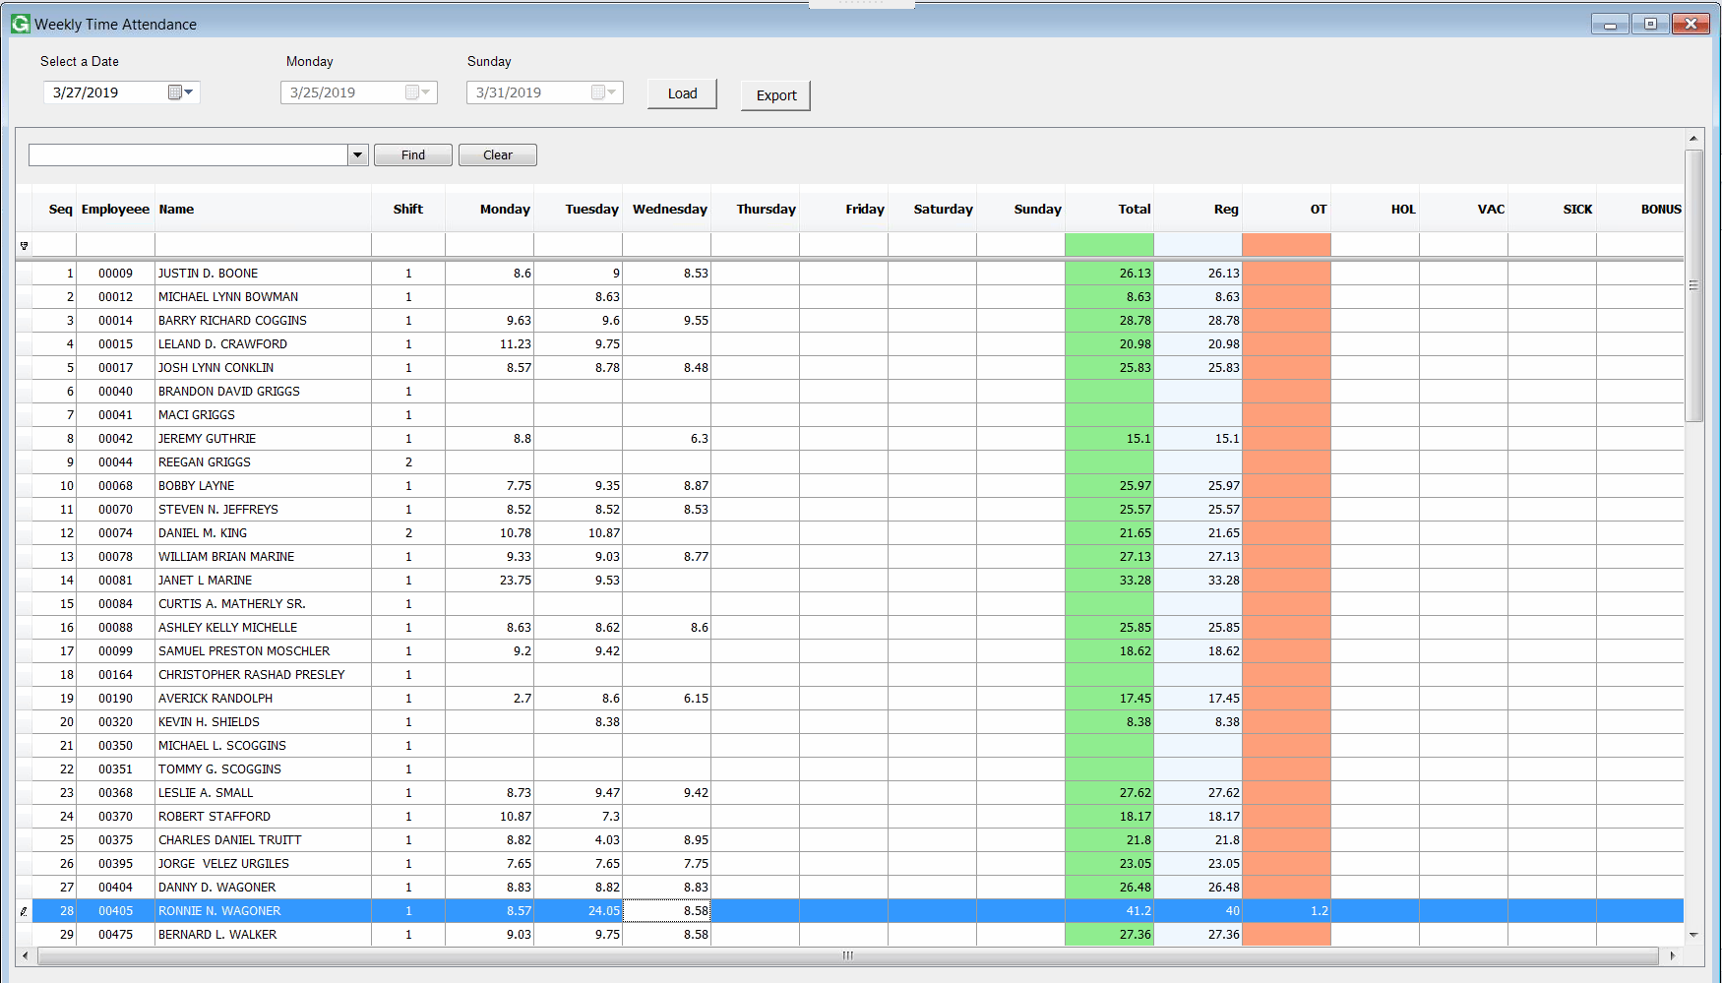

Exported to Excel:

